Setting the time:
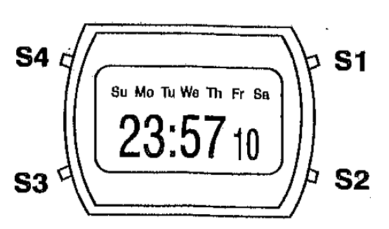
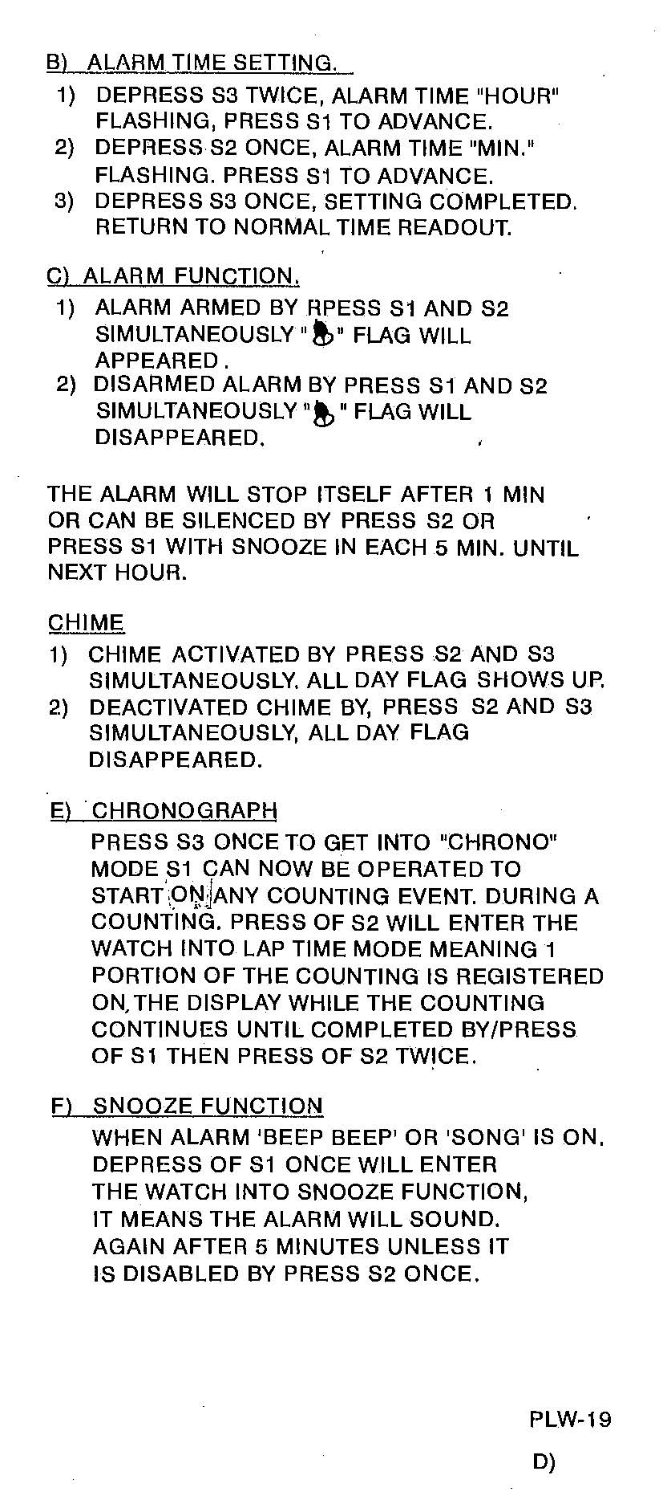
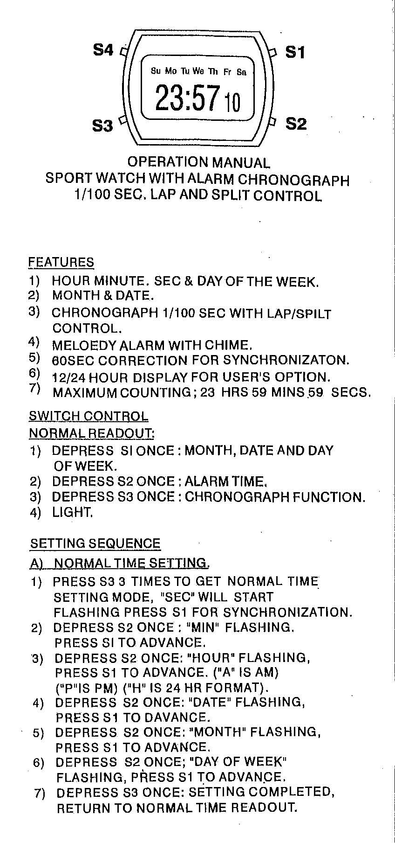
1. Press S3 three times. “SEC” will start flashing. Press S1 to set the
seconds to zero (for synchronization)
2. Press S2 once. “MIN” will s tart flashing. Press S1 to set minutes.
3. Press S2 once. “HOUR” will start flashing. Press S1 to set hour.
(A is for AM, P is for PM, H is for 24-hour format)
4. Press S2 once. “DATE” will start flashing. Press S1 to set day of the month.
5. Press S2 once. “MONTH” will start flashing. Press S1 to set month.
6. Press S2 once. “DAY OF WEEK” will start flashing. Press S1 to set day of the week.
7. Press S3 once. Watch returns to normal time readout.

